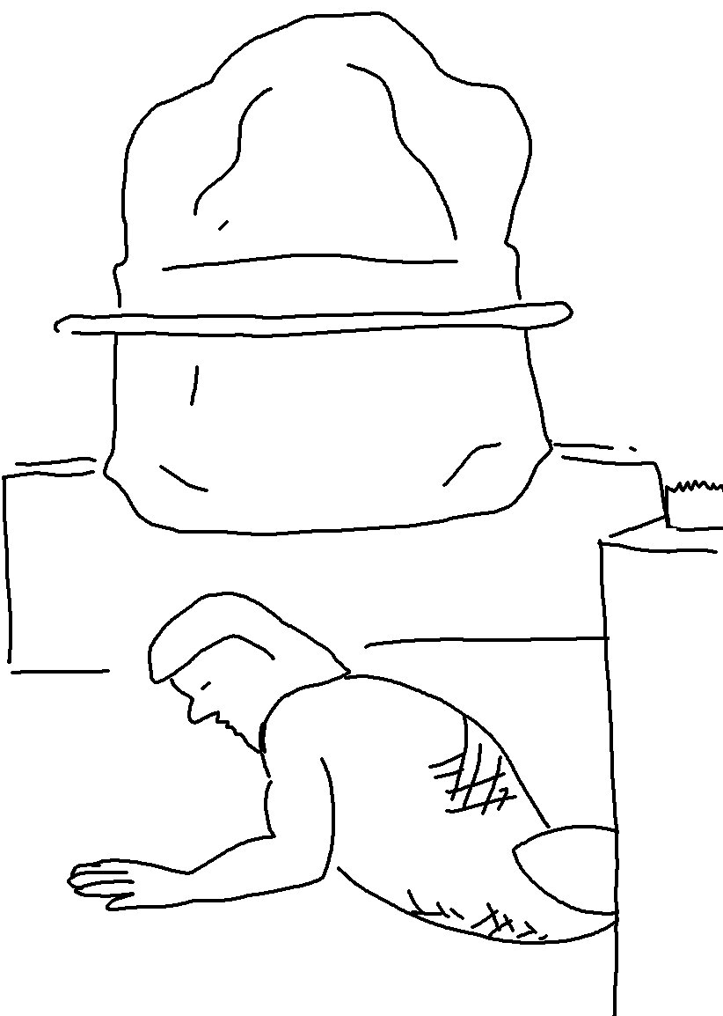

I am the _ _ _ _; that is my name! I will not give my glory to anyone else, nor _ _ _ _ _ my praise with carved _ _ _ _ _. Isaiah 42:8_{NLT}

